Experiment: Database Connectivity with MS Access

Create Database and Table in MS Access as follows:

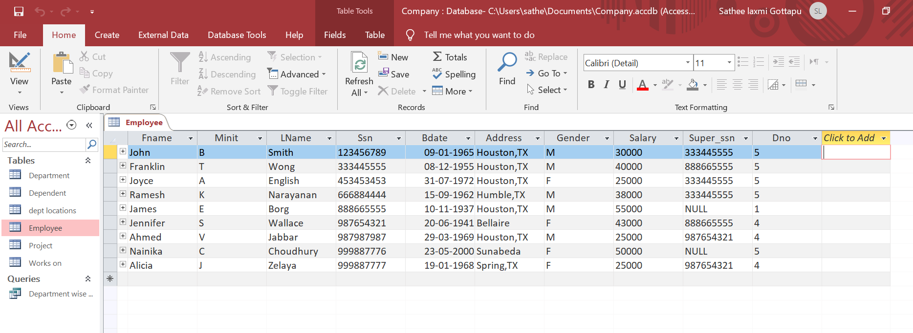

Connect to Database in visual studio

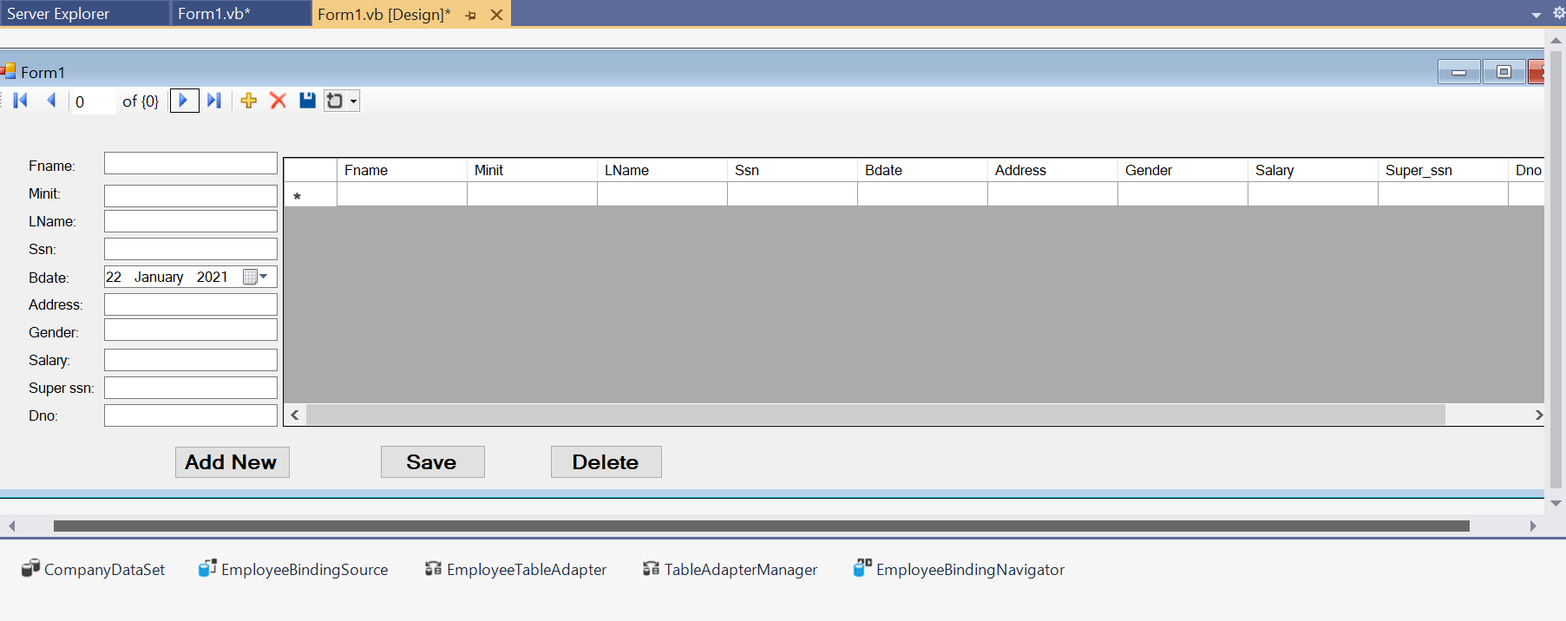

Program:

Public Class Form1

Private Sub EmployeeBindingNavigatorSaveItem_Click(sender As Object, e

As EventArgs) Handles EmployeeBindingNavigatorSaveItem.Click

Me.Validate()

Me.EmployeeBindingSource.EndEdit()

Me.TableAdapterManager.UpdateAll( Me.CompanyDataSet)

End Sub

Private Sub Form1_Load(sender As Object, e As EventArgs) Handles MyBase.Load

'TODO: This line of code loads data into the

'CompanyDataSet.Employee' table. You can move, or remove it, as needed.

Me.EmployeeTableAdapter.Fill(Me.CompanyDataSet.Employee)

End Sub

Private Sub Button1_Click_1(sender As Object, e As EventArgs) Handles Button1.Click

EmployeeBindingSource.AddNew()

End Sub

Private Sub Button3_Click(sender As Object, e As EventArgs) Handles Button3.Click

EmployeeBindingSource.RemoveCurrent()

End Sub

Private Sub Button2_Click(sender As Object, e As EventArgs) Handles Button2.Click

Try

EmployeeBindingSource.EndEdit()

EmployeeTableAdapter.Update(CompanyDataSet.Employee)

MessageBox.Show("Data Saved")

Catch ex As Exception

MessageBox.Show("Error occured while saving data " )

End Try

End Sub

End Class

Output:

